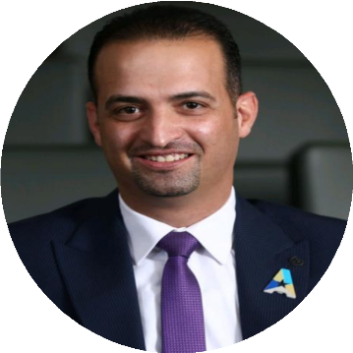  CAREER SUMMARY  20 years of experience in consulting and trainings and experienced Branch Manager with broad-based success in leading strategies that increase sales, revenue and profitability results. Analytical, decisive thinker with the ability to gain the trust and cooperation of staff, and grow revenue through strong client relations and operations management activities. Excels within highly competitive environments where leadership skills are the keys to success.  Contact details  MOBILE: +962 7 9921 2776  EMAIL: david_alhout@hotmail.com  PERSONAL DETAILS  DATE OF BIRTH: 07/04/1982  NATIONALITY: Jordanian  MARITAL STATUS: Married  languages  ARABIC: Native  ENGLISH: Very Good  references  Available upon request |  | Daoud AlHout  EDUCATION  Master’s degree in Marketing  June 2023  Charisma University - United Kingdom  Bachelor’s degree in Administrative and Financial Sciences  2000-2004  Amman University  WORK EXPERIENCE  Arab Bank  Consumer Banking Program Manager  Business development, PPP business cases, Program Success (May 2023 till now)  Housing Bank for Trade and Finance  Branch Manager/Gardens - Large Branch (June 2019 – May 2023)  Digital Gates  Sales Manager Consultant (February 2020 – Sep 2022)  Jordan Commercial Bank  Direct Sales Manager (June 2018 – June 2019)  National Bank of Abu Dhabi  Branch Manager (January 2012 - June 2018)  Assistant Branch Manager (December 2011 - January 2012)  Standard Chartered Bank  Customer Relationship Manger (January 2010 - December 2011)  HSBC Bank Middle East Limited  Premier Relationship Manger (June 2009 - January 2010)  Assistant ECC Officer and Assistant Cash Officer (June 2008 - June 2009)  Electronic Clearing Cheques - Quality Assurance (September 2007 - June 2008)  Senior Teller Associate (March 2005 - September 2007)  trainings & certificates  - Certified Branch Manager – June 2022  - International Certified Sales Manager – April 2018  - International Certified Branch Manager – June 2018  - Certified International Sales Manager – June 2016  - Certified Branch Manager (Diploma)- May 2014  - Bancassurance Certificate- June 2011  Awards  - Housing Bank Alpha award - 2022  - NBAD Talented Team - 2016  - The Right Partner for July 2010  - Good Performance for the Jun 2010  - Top Performer 2007  - SHUKRAN For being Customer-Driven  - Quarterly FEKRETY Awards (Gold, Silver and Bronze)  - Top Performer in financial planning 2006

